Think Measles
Measles is a highly infectious, notifiable, vaccine-preventable, acute viral disease. Measles is transmitted via airborne respiratory particles or direct contact with nasal/throat secretions of infected individuals. Measles has been declared a national incident after a surge in cases across the UK and the low uptake.

Measles symptoms can include:
- Fever
- Conjunctivitis
- Cough
- Runny nose
- Sneezing
- Spots in the mouth
- Rash

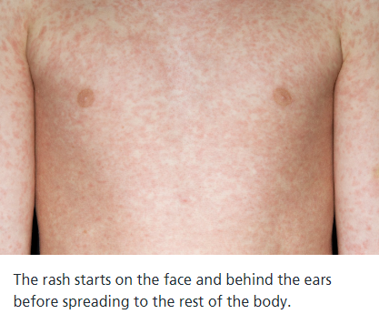

Patients are unlikely to get Measles if they have had both does of the MMR vaccination or they have had measles before.

How to avoid spreading or catching Measles
Do
- Wash your hands often with soap and warm water
- Use tissues when you cough or sneeze
- Throw used tissues in the bin
Don’t
- Do not share cutlery, cups, towel, clothes or bedding

